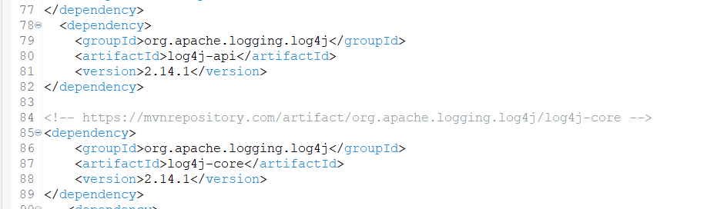adding dependency in the maven project

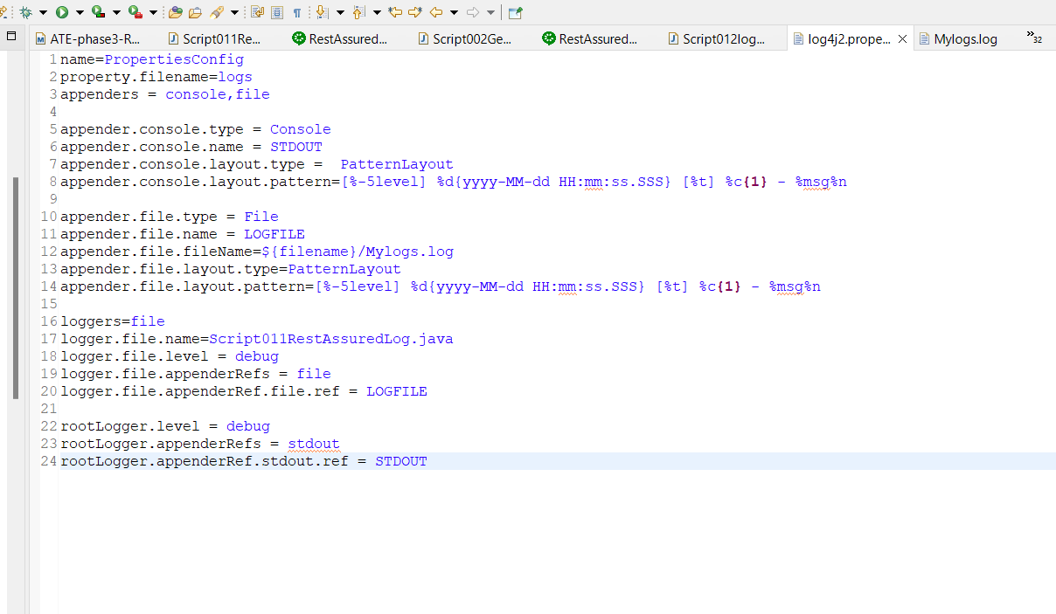

Creating a source folder

Giving name as –src/main/resource